Curved Mirror Problems Worksheet

1. Where is the image of 5' 2" tall woman located when she stands 3.2' in front of a full-length plane mirror?

1. You have a convex mirror that has a focal length of 5.0 m (is that positive or negative?); if you place an object 15 m in front of that mirror, where is the image located? What type image is it? Besides calculating the answer, solve for it graphically by finishing this drawing.
2. 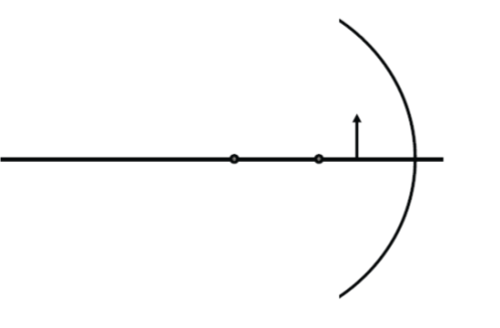Predict the location of the image of a candle flame placed 14 cm in front of a concave mirror that has a focal length of 21 cm. What type of image is it? Calculate the answer and finish the drawing.

4. Given *do* =18 cm, *di* = -6 cm and *ho* = 3 cm. Find the focal length of this mirror and state whether it's concave or convex. Also find *hi*.

1. A 5-cm tall light bulb is placed 36 cm away from a mirror that has a focal length of 12 cm. Where is the image located and how large is it? Calculate the answer and finish the drawing.